Template for Evidence(s)
UI GreenMetric Questionnaire

University : ...
Country : ...
Web Address : …

[4] Water (WR)
SAMPLE
[4.2] Water Conservation Program Implementation (WR.2)

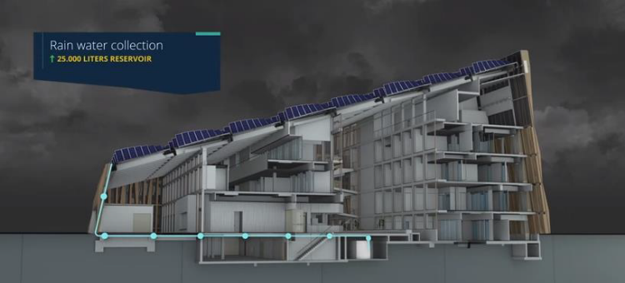
Example of Water Conservation – Rain Water Collection (University of Groningen, Netherlands)
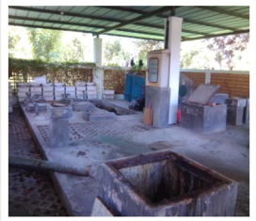 | 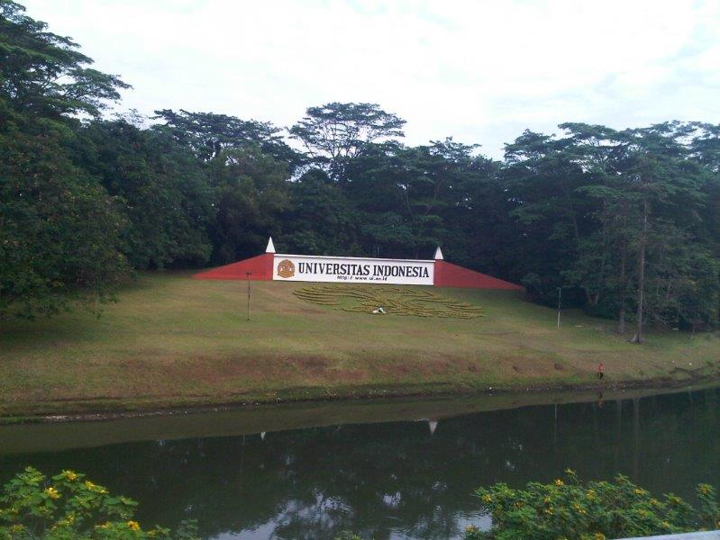
Example of Water Conservation - In Ground Water Tank (Institute Teknologi Sepuluh Nopember, Indonesia) | Example of Water Conservation – Lake (Universitas Indonesia, Indonesia)

University and Location | Average Rainfall (mm/hr) | Water Flow Rate (liters/hr) | Number of Reservoirs | Capacity of Reservoirs (liters) | Number of Lakes | Capacity of Lakes (liters) | Number of Recharging Pits | Capacity of Recharging Pits (liters)
University X; Campus V | 50 | 5000 | 3 | 200000 | 2 | 150000 | 5 | 50000
University X; Campus F | 60 | 6000 | 2 | 180000 | 1 | 100000 | 4 | 40000
University X; Campus D | 55 | 5200 | 3 | 220000 | 2 | 160000 | 5 | 55000

Description:
(Please describe the water conservation program on your campus. The following is an example of the description. You can describe more related items if needed.)

The evidence provided may also include maps showing the location, area size, or distribution of facilities relevant to the indicators

Notes: The attached evidence can be the programs and implementations for water conservation in the university. University can provide information on the average rainfall, speed or rate of water flowing out of the location in one hour. University should also provide information on the number of reservoirs, lakes, and other conservation implementation programs (such as, among others, the numbers of recharging pits) along with their respective capacities. University can provide information on the programs that has been implemented, the location of the programs, the type of programs implemented, the targets to be achieved with the program, how the program was implemented, the results of the program, and evaluations of the implemented program. If this question is not relevant to your university, please provide explanations. Please provide some pictures or photos to support the evidence and other relevant information to support the evidence.

- All buildings of the University of Groningen have a separated sewerage system, for waste water and for clean water (rainwater). Rain water is thus collected from the roofs of the buildings and is then discharged into the local ponds and canals around the buildings. The university has also buildings where all the rainwater is collected for toilet flushing and for watering the plants inside the building. At our campus we have a separate sewerage system. We collect rainwater from the roof, parking area etc. and discharge this in the ponds and channels at our campus.

Additional evidence link (i.e., for videos, more images, or other files that are not included in this file):

